SEPA Mandate Checklist

1 | Layout | Yes | No
1.1 | The Mandate is contained on a single page and any other text/information which is not specifically mentioned below is clearly de-lineated from the mandate.
1.2 | The following note {or similar) is present on the mandate – “Please return this mandate to the Creditor”.
1.3 | The following note {or similar) is present on the mandate – “Your rights are explained in a statement that you can obtain from your bank”.
1.4 | The following LegaI text is present on the mandate “By signing this mandate form, you authorise (A) {NAME OF CREDITOR} to send instructions to your bank to debit your account and (B) your bank to debit your account in accordance with the instructions from {NAME OF CREDITOR}. As part of your rights, you are entitled to a refund from your bank under the terms and conditions of your agreement with your bank. A refund must be claimed within 8 weeks starting from the date on which your account was debited.”
1.5 | ‘(NAME OF CREDITOR)’ placeholders with in the title and legaI text are replaced with the Creditor name.
2 | Verify the Mandate Heading Contains the Following | Yes | No
2.1 | The title “SEPA Direct Debit Mandate”, “(SEPA) Direct Debit Mandate”, or “Direct Debit Mandate (SEPA)”.
2.2 | The text “Please complete all the fields marked*”.
3 | Mandate with Mandatory Fields Only  Note that these fields can be arranged in any order and can be re-named so long as the purpose of the field is clear and relates directly to one of the attributes below. | Yes | No
3.1 | The following Mandatory fields are present on the Mandate and no additional fields are present.
3.2 | Note that the following fields with the exception of ‘Address of Debtor’ and ‘BIC of the Debtor Bank’ are marked with an *  - Name of the Debtor  - Address of Debtor †(Mandatory when collecting from a non EEA SEPA country or territory)  - IBAN of Account to be Debited  - BIC of the Debtor Bank  - Date of signing & signatures.  (Mandatory to provide two signature boxes in the event it is a joint account)
3.3 | The following fields are pre-populated by the creditor except where otherwise indicated:  - Unique Mandate Reference (UMR)-Can be populated by the Creditor after receipt of signed mandate Creditor Identifier  - Name of Creditor  - Address of Creditor  - Type of payment (recurrent or one-off) – Typically this field should be pre-populated by the Creditor unless the particular business requirements allow for the decision to be made by the Debtor.
4 | Mandate with Additional Optional Fields  Note that these fields can be arranged in any order and can be re-named so long as the purpose of the field is clear and relates directly to one of the attributes below. | Yes | No
4.1 | AdditionaIOptional Fields are underthe following heading (or similar) -”For Information Purposes Only”.
4.2 | If Additional Optional Fields are to be used they are limited to the list below and are separated from the main section of the mandate, below the Signature area.  - Debtor identification code  - Name of the Debtor Reference Party  - Identification code of the Debtor Reference Party  - Name of the Creditor Reference Party  - Identification code of the Creditor Reference Party  - Underlying contract identifier  - Contract description.

SEPA Direct Debit Mandate

SEPA Direct Debit Mandate

Unique Mandate Reference (UMR) - to be completed by (NAME OF CREDITOR)
Insert Creditor’s Name and Logo

By signing this mandate form, you authorise (A) {NAME OF CREDITOR} to send instructions to your bank to debit your account and (B) your bank to debit your account in accordance with the instructions from {NAME OF CREDITOR}.
As part of your rights, you are entitled to a refund from your bank under the terms and conditions of your agreement with your bank. A refund must be claimed within 8 weeks starting from the date on which your account was debited. Your rights are explained in a statement that you can obtain from your bank.

Please complete all the fields marked *.
C R E DITO RN A M E
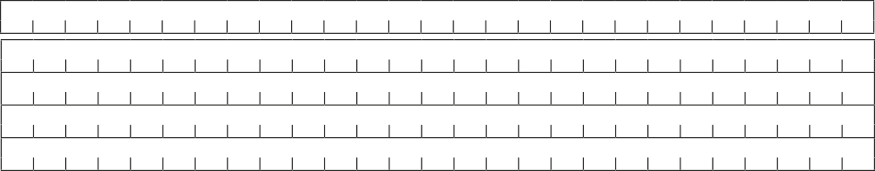
Creditor’s name Creditor’s identifier Creditor’s address
C R E DITO R
ID
C R E
C IT
P O S
C O U
D Y T
N
ITO R
A D DR ESS
C
R
O
Y
D
E
T
City
Post Code Country
Type of payment * Recurrent payment or One-off payment

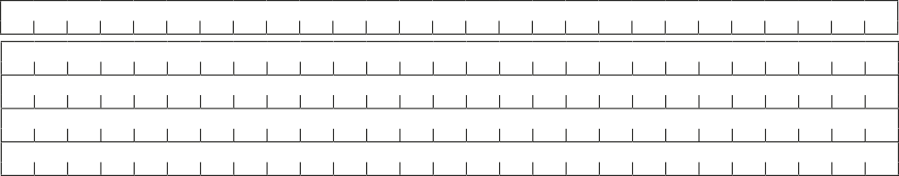
Debtor name *
Debtor address† City
Post Code Country
Debtor account number – IBAN *

Debtor bank identifier code – BIC Date of signature *
DDMMYY
Signature(s)

Please sign here * 
Note: Where the account being debited is a joint account and more that 1 person is needed to withdraw funds, then all parties must sign this form.
Address of Debtor† (Mandatory when collecting from a non EEA SEPA country or territory)

Details regarding the underlying relationship between the Creditor and the Debtor – for information puposes only.

Debtor identification code

Write any code number here which you wish to have quoted by your bank.

Person on whose behalf payment is made

Name of the Debtor Reference Party: If you are making a payment in respect of an arrangement between (NAME OF CREDITOR) and another person (e.g. where you are paying the other person’s bill) please write the other person’s name here if you are paying on your own behalf leave blank.

Identification code of the Debtor Reference Party:
Name of the Creditor Reference Party

Creditors must complete this section if collecting payment on behalf of another party.

Identification code of the Creditor Reference Party

In respect of the contract

Description of contract

Identification number of the underlying contract.

Please return this mandate to the creditor Creditor’s use only

